PChess
User's Manual
Chess for MSX2 with the MSXPi interface
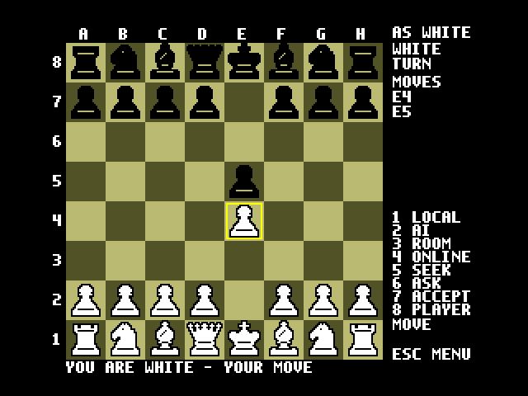
Version 1.1 — September 2026

1. Introduction
PChess is a chess program for MSX2 computers. Normally it works with an MSXPi interface: the MSX draws the board and reads the keyboard or joystick, and the MSXPi server on the Raspberry Pi (or PC) checks every move against the full rules of chess, runs the computer opponent and handles network play. PChess can also run without the MSXPi server, on an MSX with a TCP/IP network stack; the MSX then checks the rules itself (section 10).
You can play in four ways:
- Local: two people take turns at the same MSX.
- AI: you play white against the computer (Stockfish, with eight strength levels).
- Room: two players join the same named room, through a small relay on the local network or through an IRC channel (section 8).
- Online: players meet in the #msxpi channel on an IRC network (Libera.Chat by default), find each other, send an invitation and play by private messages.
The rules are all included: check, checkmate, stalemate, castling, en passant, promotion (also to a knight, bishop or rook) and claimable draws, which are accepted automatically.

1.1 Requirements
- An MSX2 or later (V9938 VDP). 64 KB of VRAM is enough. On an MSX1, PChess says PCHESS NEEDS AN MSX2; use PCHESS1 instead (section 9).
- An MSXPi interface and a running MSXPi server, version 1.6 or later; or, for the TCP/IP link, a TCP/IP UNAPI network stack such as InterNestor Lite (section 10).
- On the server, the Python package chess (from requirements-pchess.txt) and, for a strong computer opponent, Stockfish. The MSXPi setup script installs both.
- For Room or Online play, a network connection on the server.

2. Installation

2.1 Server
The MSXPi setup script installs everything. To install by hand on a Raspberry Pi:
sudo apt install stockfish
pip install -r /home/pi/msxpi/requirements-pchess.txt
Without Stockfish, PChess falls back to a much weaker built-in engine. Restart the MSXPi server after you install anything.

2.2 MSX
Copy PCHESS.COM to any MSX-DOS disk. The file is in software/target in the MSXPi repository, and it can be built from software with make.bat pchess.

3. Starting PChess
Boot MSX-DOS, go to the drive that holds PCHESS.COM and type PCHESS:
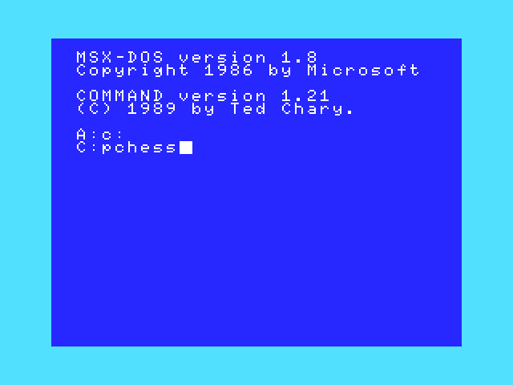
Figure 1: Starting PChess from the MSX-DOS prompt
After a few seconds the board appears. The status line at the bottom shows 1 LOCAL 2 AI, and no game is running yet. Choose a mode with the number keys listed in the right-hand panel.
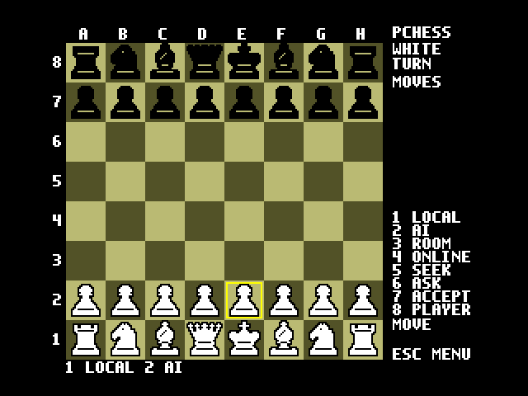
Figure 2: The PChess screen after start-up

3.1 The screen
- The board: files A–H are shown above it and ranks 1–8 to its left. A yellow frame marks the cursor.
- Top of the panel: PCHESS before a game; AS WHITE or AS BLACK once you are matched. Below it, the side to move (WHITE/BLACK) and TURN, or GAMEOVER when the game has ended.
- MOVES: the most recent moves of the game.
- Key list: 1 LOCAL, 2 AI, 3 ROOM, 4 ONLINE, 5 SEEK, 6 ASK, 7 ACCEPT, 8 PLAYER.
- Entry field: under the key list, labelled MOVE, ROOM or PEER for what you are typing.
- Status line at the bottom: messages such as WHITE TURN, WAIT ACK, INVITE SENT, DRAW AGREED.

3.2 Keys at a glance
Key | Action
1 | New local two-player game
2 | New game against the computer (you play white)
3 | Room mode: type a room name and press Return
4 | Online: connect to IRC and join #msxpi
5 | SEEK: announce in #msxpi that you want a game (at most once a minute)
6 | ASK: type a player's nickname and press Return to invite them
7 | ACCEPT the invitation shown on the status line
8 | PLAYERS: list the players who are seeking or have invited you
Arrows / joystick | Move the cursor
Space / Return / fire A | Select a piece, then its destination square
Letters and digits | Type a move (e2e4, Nf3, O-O, a7a8n), then Return
Backspace | Correct the move being typed
ESC | Menu: AI level, rooms, link, offer draw, resign, rotate board, credits, exit

4. Playing against the computer (AI)

4.1 Starting a game
Press 2. A new game starts with you as white (AS WHITE), and the status line reads WHITE TURN.
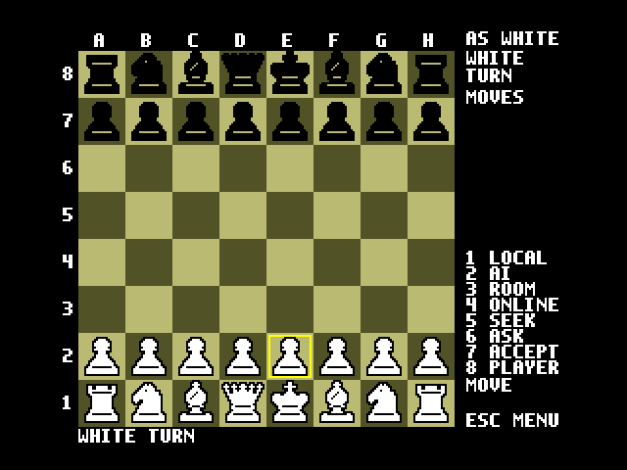
Figure 3: A new game against the AI

4.2 Choosing the AI level
- Press ESC to open the menu. The first row, AI LEVEL, shows the current level.
- With AI LEVEL highlighted (= marks the chosen row), press Right to make the AI stronger or Left to make it weaker.
- Press Return to save the level. The status line confirms it, e.g. AI LEVEL 4 ELO 1350.
- Press ESC to return to the game.
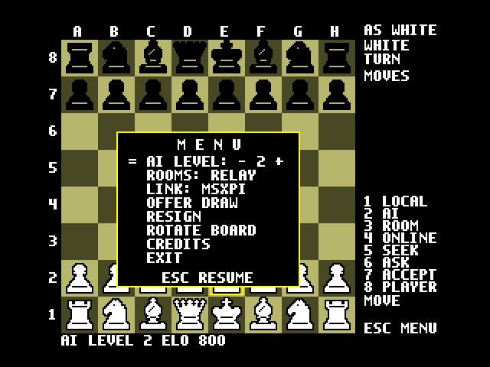  Menu open, level 2 | 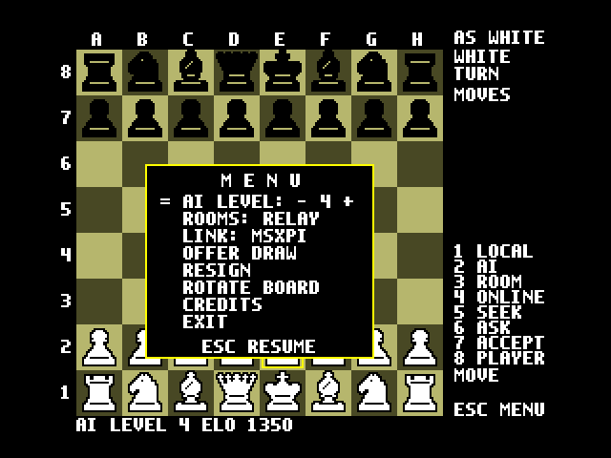  Level 4 saved
Figure 4: Changing the AI level
The level is saved on the server (PCHESSELO in msxpi.ini), so it stays set for later games. Levels and their approximate ratings:
Level | Approximate strength (Elo)
1 / 2 / 3 | 600 / 800 (default) / 1000
4 / 5 / 6 | 1350 / 1600 / 1900
7 / 8 | 2200 / 2500
Stockfish cannot play below about 1320. For levels 1–3, PChess uses its weakest setting with a shallow search, so those ratings are rough. The AI thinks for PCHESSMOVETIME seconds per move (default 1).

5. Moving pieces
There are two ways to enter a move, and you can use either one at any time.

5.1 With the cursor (keyboard or joystick)
- Move the yellow cursor onto one of your pieces with the arrow keys (or joystick port 1).
- Press Space, Return or fire button A. The piece's square turns green.
- Move the cursor to the destination square.
- Press Space/Return/A again. The piece moves and the move is added to the MOVES list.
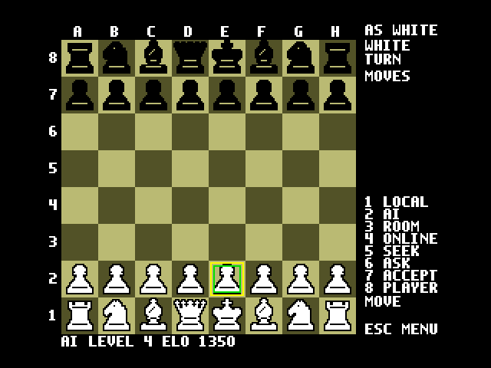  Step 2: pawn on e2 selected (green) | 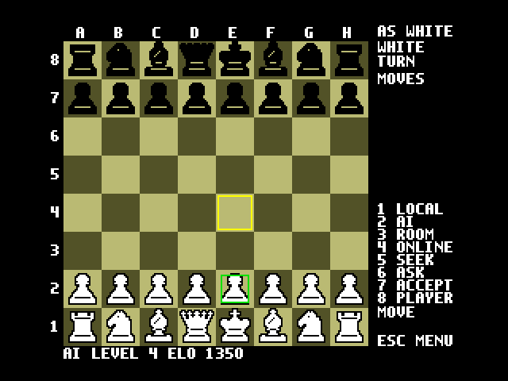  Step 3: cursor on e4
Figure 5: Moving with the cursor
To pick a different piece, select it instead of choosing a destination. A pawn promoted with the cursor always becomes a queen; to under-promote, type the move (a7a8n).
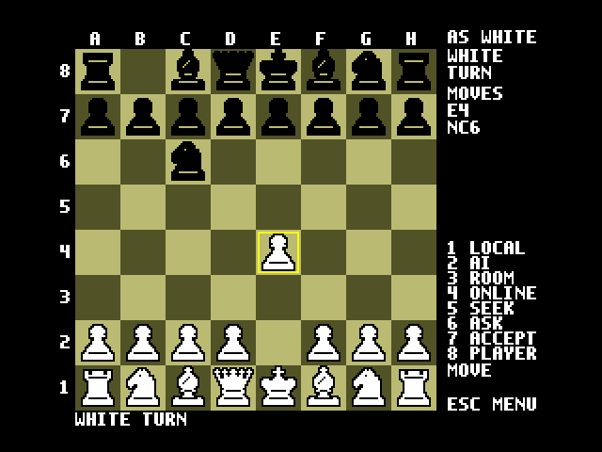
Figure 6: After 1. e4 the AI replied Nc6

5.2 By typing the move
Type the move and press Return. PChess accepts two notations:
- UCI (from-square, to-square): e2e4, g1f3, promotion a7a8q or a7a8n.
- SAN (standard algebraic): e4, Nf3, Bxc6, O-O, O-O-O.
What you type appears next to MOVE in the panel. Use Backspace to correct it. An illegal move is rejected and the position does not change.
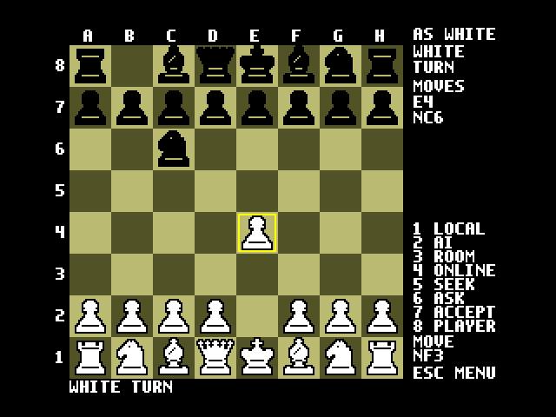  Typing Nf3 | 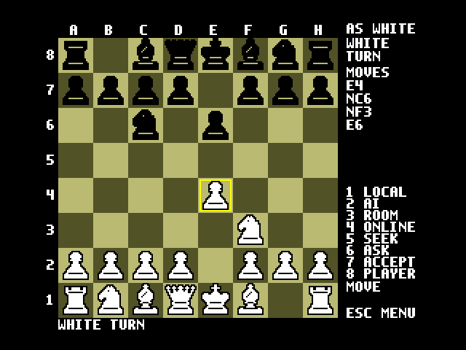  After Return; the AI answered e6
Figure 7: Entering a move by typing

6. Offering a draw and resigning

6.1 Offering a draw
- Press ESC, move down to OFFER DRAW and press Return.
- The status line asks OFFER DRAW? Y/N. Press Y to confirm; any other key cancels (GAME GOES ON).
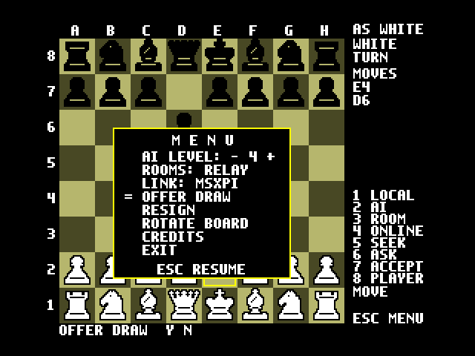  Confirming the offer | 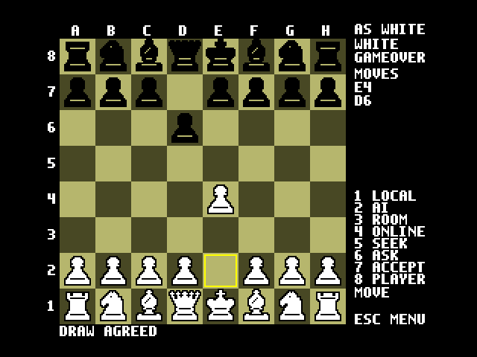  The AI accepted: DRAW AGREED
Figure 8: Offering a draw to the AI
How the offer is answered depends on the mode:
- Local: the game is drawn at once.
- AI: the computer accepts unless it is more than half a pawn ahead. Otherwise the status line reads AI DECLINES THE DRAW and play continues.
- Room/Online: you can only offer on your own move. The opponent sees OPPONENT OFFERS DRAW - ESC MENU and accepts by choosing OFFER DRAW too, or declines by making a move (section 7.6).

6.2 Resigning
- Press ESC, move down to RESIGN and press Return.
- The status line asks RESIGN? Y/N. Press Y to resign.
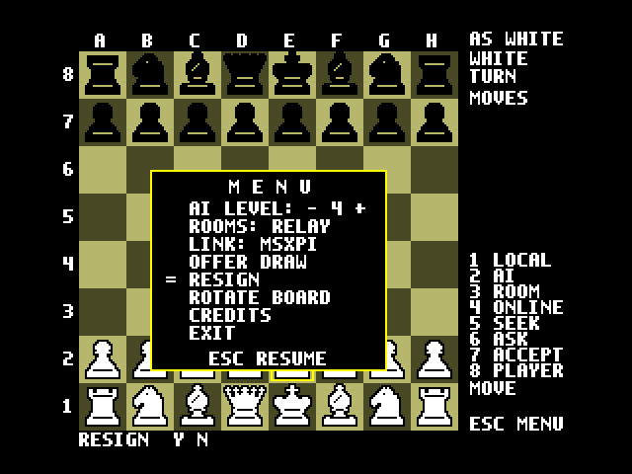  RESIGN? Y/N | 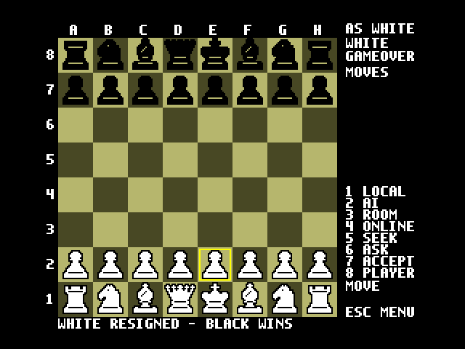  WHITE RESIGNED - BLACK WINS
Figure 9: Resigning
In a local game, the side to move resigns. If no game is running, the status line reads START A GAME FIRST. The PSG plays a rising tune when you win and a falling one when you lose.

7. Playing online (IRC)
In Online mode, PChess connects to an IRC network from the MSXPi server and joins the public channel #msxpi. The channel is only used to say you are available (SEEK). Invitations, moves, draw offers and resignations go by private message between the two players, and ordinary channel chat is ignored.

7.1 Server configuration
Online play works without an account. Both players must use the same IRC network. In msxpi.ini:
var IRCADDR=irc.libera.chat
var PCHESSIRCPORT=6697
var IRCNICK=yournick
Pick a unique nickname: a letter, then letters, digits, _ or -, up to 16 characters (many IRC networks allow only 9). TLS is used by default on port 6697. If the network asks for an account (status LOBBY ACCOUNT LOGIN REQUIRED (477), e.g. during spam waves), register a free Libera.Chat account and add IRCACCOUNT and IRCPASSWORD. Restart the server after editing msxpi.ini. All the options are described in software/docs/PCHESS-IRC.md.
The example below shows two players, alice (left screens) and bob (right screens).

7.2 Step 1: go online
Press 4. After a few seconds the status line shows LOBBY <your nick>. Wait for this before seeking or inviting. If the connection fails, the error is shown on the status line.
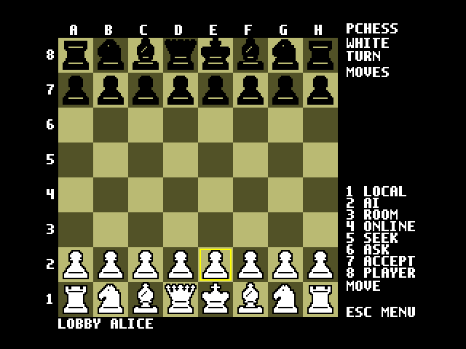  alice | 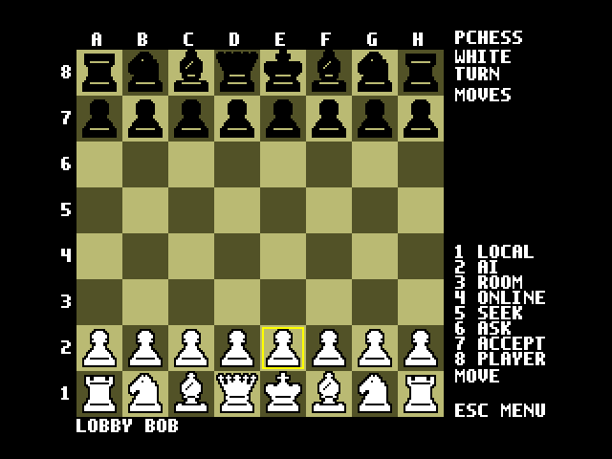  bob
Figure 10: Both players are in the lobby

7.3 Step 2: seek a match
To tell everyone in #msxpi that you want a game, press 5. The status line reads SEEK SENT. You can seek once a minute; pressing 5 again sooner is refused.
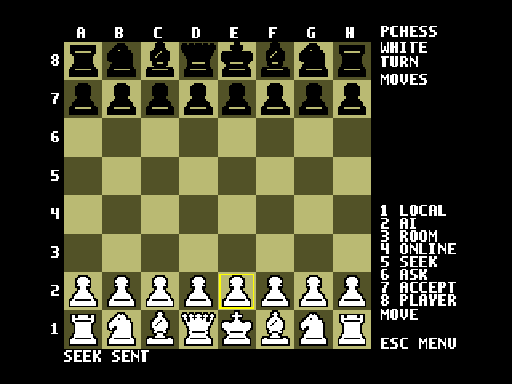
Figure 11: bob announces a wish to play (key 5)

7.4 Step 3: find out who is seeking
Press 8 to open the PLAYERS list. It shows up to seven players who sent SEEK or invited you in the last ten minutes, newest first, and the status line shows the count (e.g. 1 PLAYER). The list is kept by your own server, so opening it sends nothing to IRC.
- Up/Down chooses a player (= marks the selection).
- Return invites the selected player (the same as key 6).
- ESC closes the list.
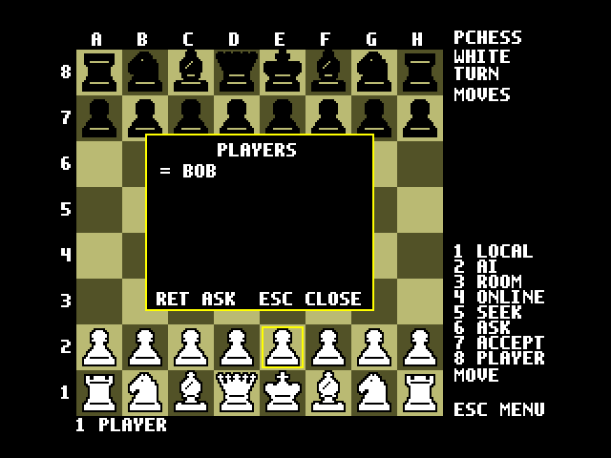
Figure 12: alice opens the player list (key 8) and sees bob

7.5 Step 4: ask for a match
There are two ways to invite a player:
- From the PLAYERS list: select the player and press Return, or
- Press 6 (ENTER PEER NICK AND RETURN), type the player's nickname next to PEER and press Return. Use this when you already know the nickname, e.g. a friend who has not sent SEEK.
The status line then reads INVITE SENT.
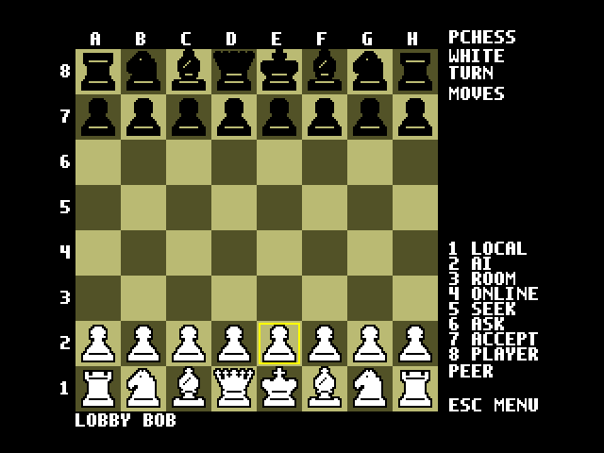  Key 6: enter the nickname | 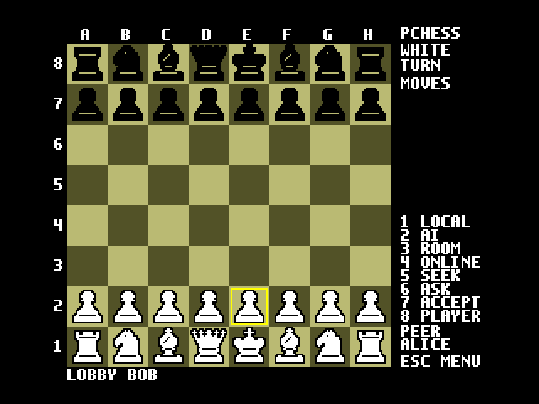  alice typed next to PEER
Figure 13: Inviting a player by nickname

7.6 Step 5: accept a match
The invited player's status line reads INVITE <nick> PRESS 7. Press 7 to accept. The game starts when both sides have confirmed (WAIT READY is shown briefly). The player who sent the invitation plays white; the player who accepted plays black.
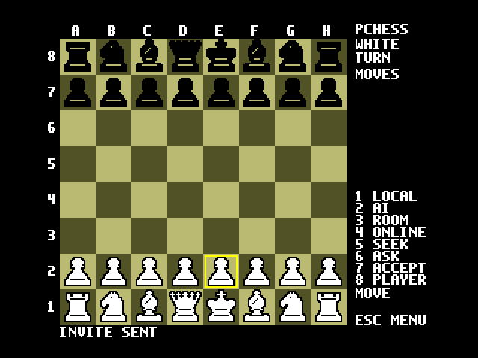  alice: INVITE SENT | 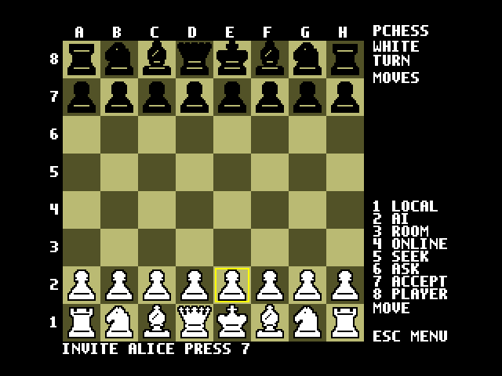  bob: INVITE ALICE PRESS 7
Figure 14: The invitation arrives
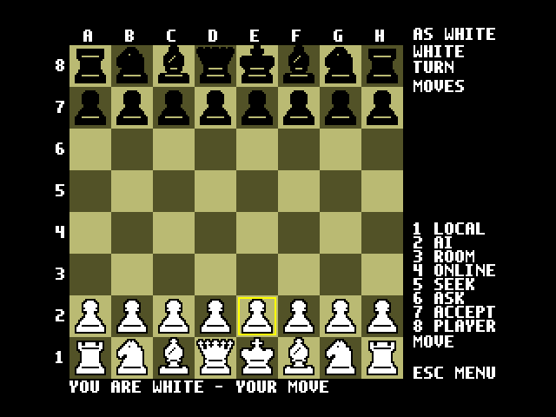  alice: YOU ARE WHITE - YOUR MOVE | 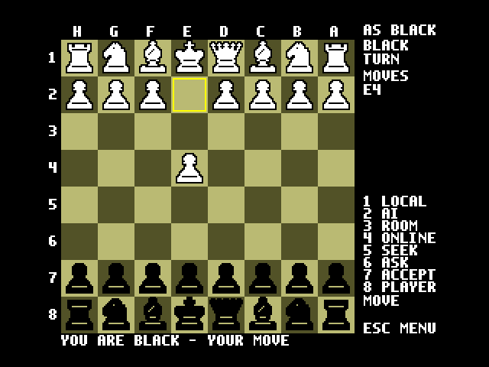  bob: AS BLACK, board rotated
Figure 15: Matched: each player sees their own pieces at the bottom
Black sees the board rotated so that its pieces are at the bottom. The cursor moves as shown on screen, and typed moves are the same either way. The panel shows AS WHITE or AS BLACK, and the status line shows whose move it is, e.g. YOU ARE BLACK - BOB MOVES.

7.7 Step 6: play
Move pieces as in section 5. After your move the status line reads WAIT ACK until the opponent's MSXPi confirms it has received the move (a lost message is resent automatically). The opponent's move then shows up within a couple of seconds.
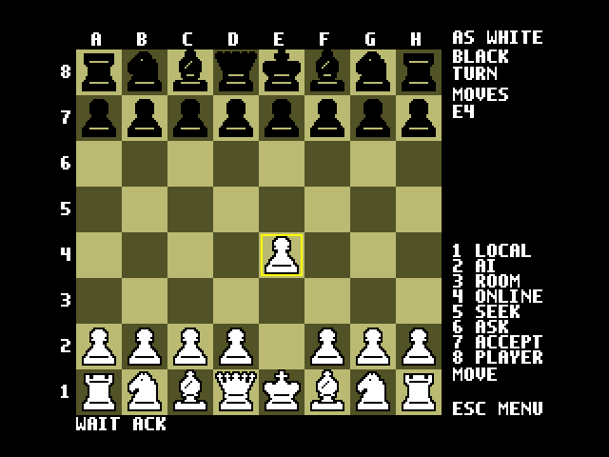  alice played e4 (WAIT ACK) | 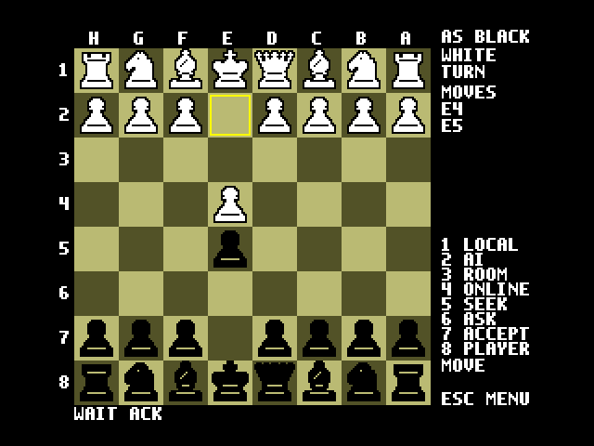  bob answered e5
Figure 16: Moves travel by private message

7.8 Offering and accepting a draw online
- On your move, press ESC, choose OFFER DRAW, Return, then Y. The status line reads DRAW OFFERED.
- The opponent sees OPPONENT OFFERS DRAW - ESC MENU and hears two beeps.
- To accept, the opponent chooses OFFER DRAW in the ESC menu and presses Y. Both screens show DRAW AGREED.
- To decline, the opponent just makes a move. The offer ends when the player it was made to moves.
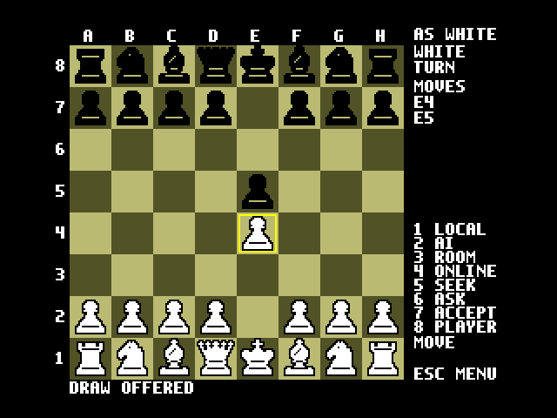  alice: DRAW OFFERED | 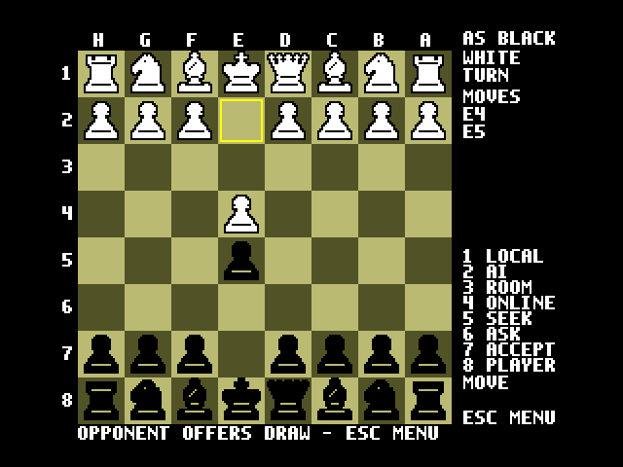  bob: OPPONENT OFFERS DRAW
Figure 17: A draw offer
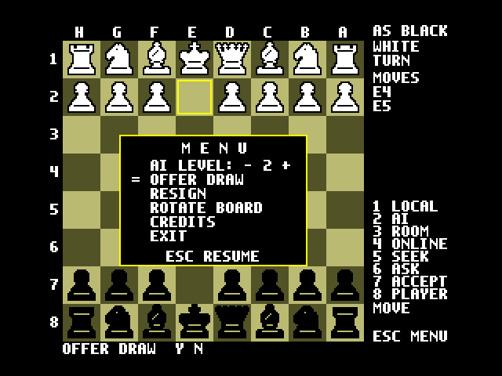  bob accepts through OFFER DRAW | 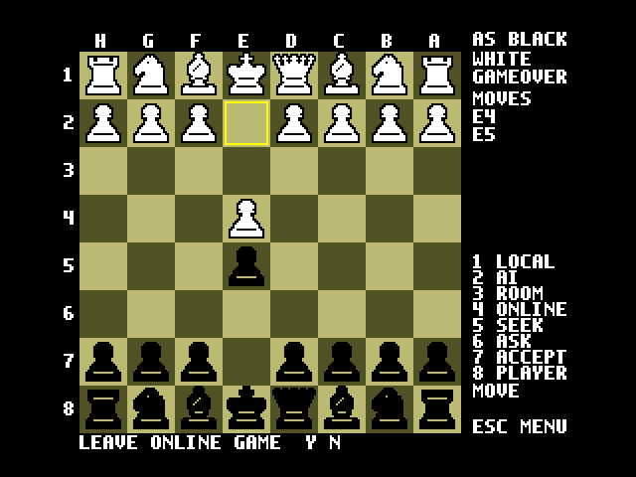  DRAW AGREED
Figure 18: Accepting the draw

7.9 Resigning online
Choose RESIGN in the ESC menu and press Y. Both screens show the result, for example BLACK RESIGNED - WHITE WINS.
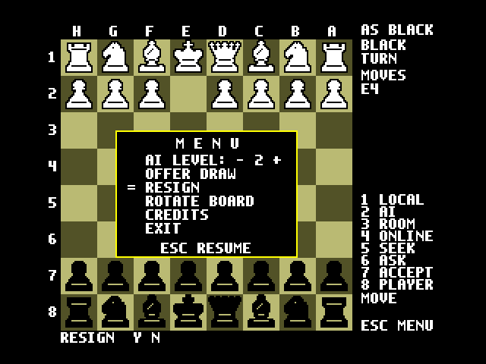  alice (black) resigns | 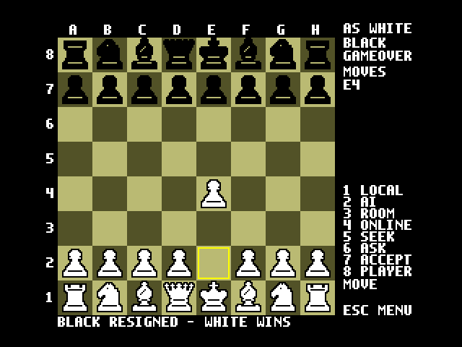  bob sees the result
Figure 19: Resigning an online game

7.10 Playing another game
When a game is over you can start the next one straight away: press 6 to invite a player (the same opponent or someone else), 7 to accept an invitation, or 5 to seek. The final position stays on the board until the new game starts. There is no need to go back to the lobby first.
To leave online play, press one of the keys 1–4. Because you are online, they first ask LEAVE ONLINE GAME? Y/N. Y goes ahead, and any other key keeps the current game (STILL ONLINE). This stops you from dropping a game in progress by pressing the wrong key.
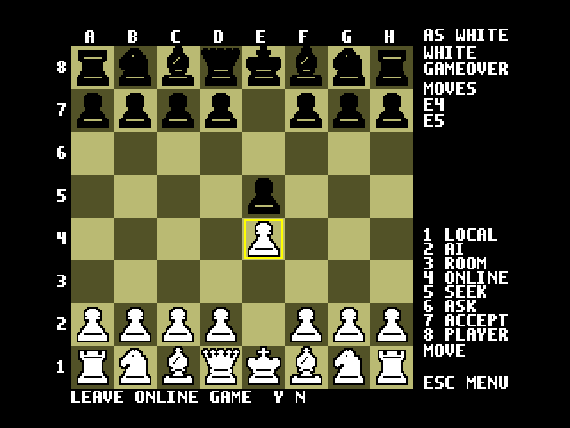  Key 4: LEAVE ONLINE GAME? Y/N | 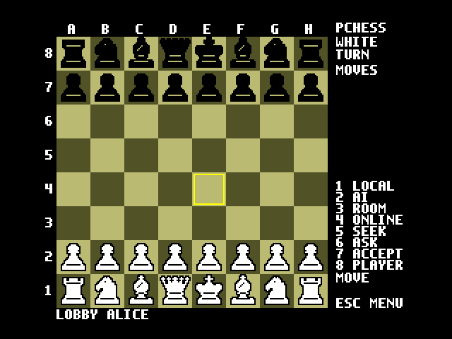  Y: back in the LOBBY
Figure 20: Leaving online play

8. Playing in a room
In Room mode two players meet by typing the same room name. A room is either a small HTTP relay on the local network (the default, sections 8.1 and 8.2) or an IRC channel (section 8.3); the ROOMS row in the ESC menu chooses which. On the relay, the first player to join plays white.

8.1 Relay configuration
One MSXPi server hosts the relay. On the host, leave PCHESSRELAY empty. The relay listens on PCHESSLISTEN:PCHESSPORT (default 0.0.0.0:5080) while that player is in Room mode:
# host (e.g. IP 192.168.1.20)
var PCHESSRELAY=
var PCHESSLISTEN=0.0.0.0
var PCHESSPORT=5080

# the other player
var PCHESSRELAY=http://192.168.1.20:5080
As an alternative, a stand-alone relay can run on any third machine. Point PCHESSRELAY on both MSXPi servers at it:
python msxpi_pchess.py --listen 0.0.0.0 --port 5080
The relay uses plain HTTP, so only use it on networks you trust.

8.2 Joining a room
- Press 3. The status line reads ENTER ROOM AND RETURN.
- Type the room name you agreed with your opponent (shown next to ROOM) and press Return.
- The first player sees WAIT PLAYER until the second joins. The second player plays black and sees YOU ARE BLACK - OPPONENT MOVES.
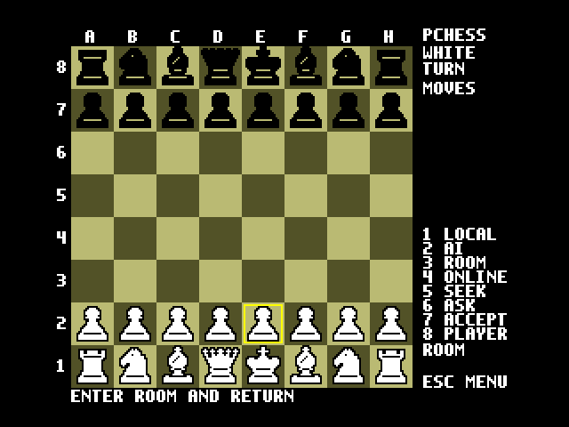  Key 3 | 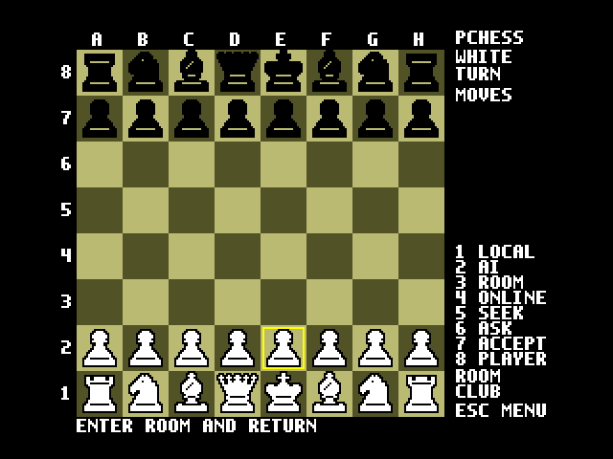  Room name "club" typed
Figure 21: Entering a room
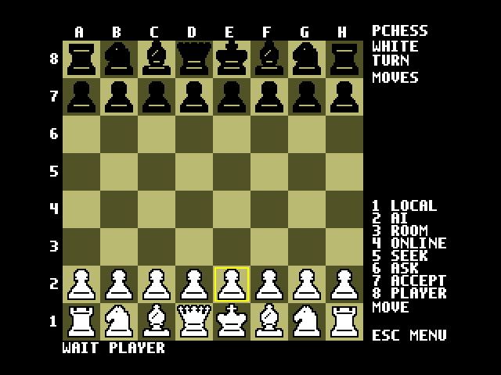  First player: WAIT PLAYER | 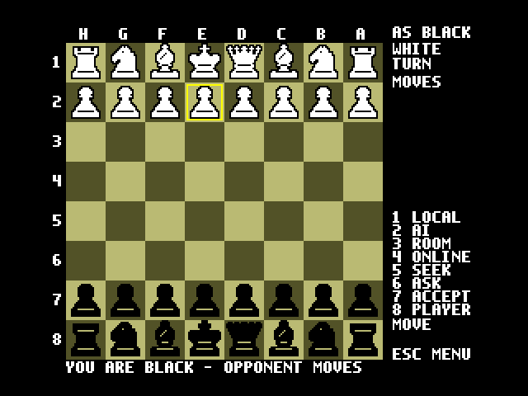  Second player joins as black
Figure 22: Joining the room
White: YOU ARE WHITE - YOUR MOVE | 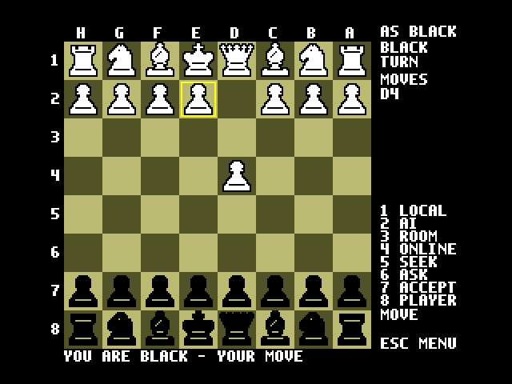  Black sees 1. d4
Figure 23: The room game starts
Moving, offering a draw and resigning work exactly as in Online mode (sections 7.7–7.9), and so does the LEAVE ONLINE GAME? Y/N question.
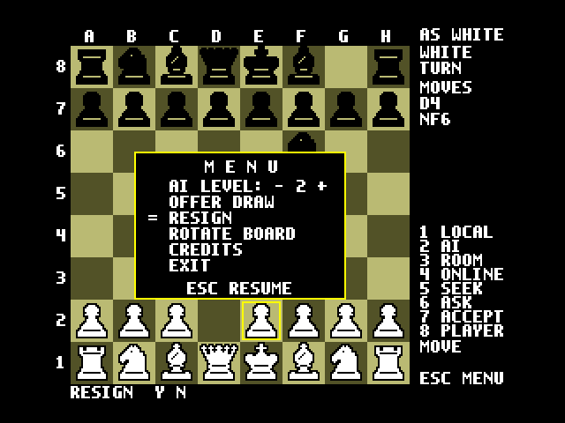  White resigns | 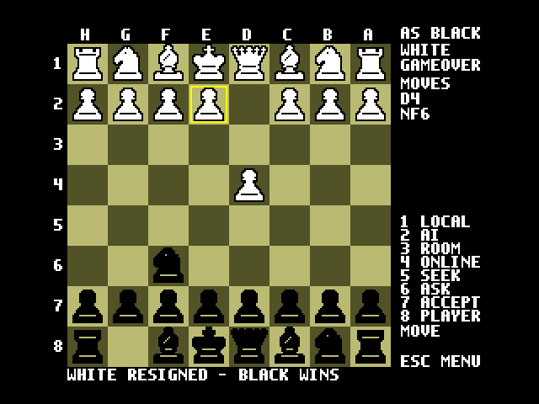  WHITE RESIGNED - BLACK WINS
Figure 24: Resigning in a room

8.3 Rooms on IRC
Choose ROOMS in the ESC menu, press Right or Left until it reads ROOMS: IRC, and press Return. The setting is saved on the server (PCHESSROOMS in msxpi.ini):
var PCHESSROOMS=irc
Room names then become IRC channels on the lobby's network (the settings of section 7.1): room club is the channel #pchess-club. IRC rooms need no relay, work across the internet, and are shared by MSXPi players and players on the TCP/IP link (section 10).
- Both players press 3, type the same room name (1-16 letters or digits) and press Return.
- The player whose nickname comes first in alphabetical order plays white. The game starts by itself; there is no invitation to accept.
- A third player who enters the room sees ROOM BUSY - GAME IN PROGRESS.
- After a game, entering the same room name again starts a rematch.
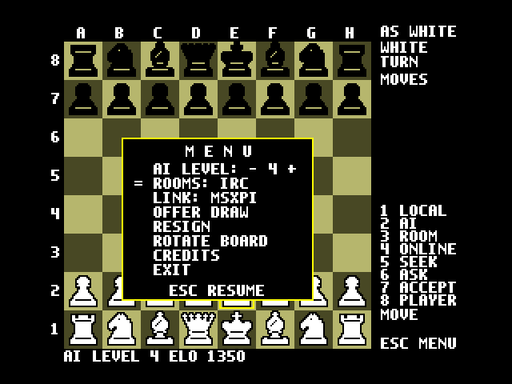
Figure 25: ROOMS: IRC selected in the ESC menu
Moving, offering a draw, resigning and leaving work as in an Online game (sections 7.7-7.10).

9. Other features

9.1 Local two-player game
Press 1. Two people share the keyboard, and each moves the side whose turn is shown in the panel. A draw offer ends the game at once, and RESIGN resigns for the side to move.

9.2 Rotating the board
Choose ROTATE BOARD in the ESC menu to turn the board over at any time, in any mode. The file and rank labels turn with it.
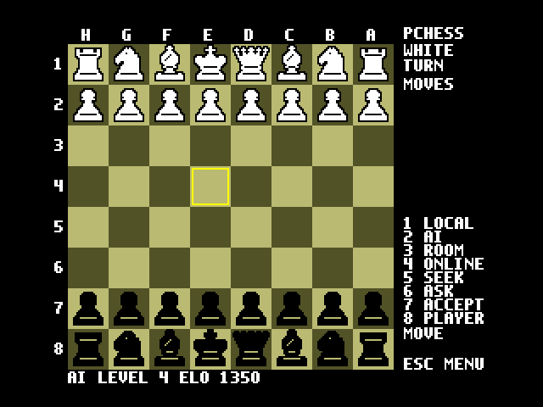
Figure 26: The board rotated (black at the bottom)

9.3 Credits and exit
CREDITS in the ESC menu shows the program credits; press any key to close them. EXIT returns to MSX-DOS. Press ESC in the menu to go back to the game.
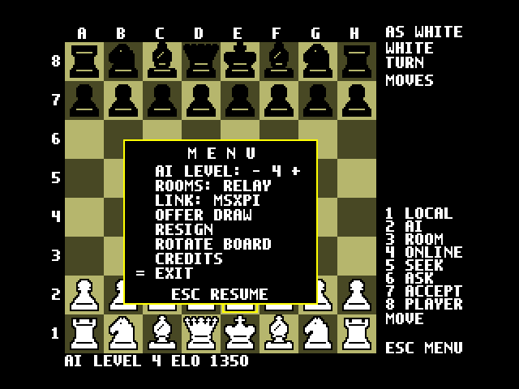
Figure 27: EXIT selected in the ESC menu

9.4 Sound
The PSG beeps twice when the opponent offers a draw. It plays a rising tune when you win and a falling one when you lose (in a local game, any win plays the rising tune).

9.5 PCHESS1 for MSX1
PCHESS1.COM is the MSX1 (TMS9918, 16 KB VRAM) version. It has the same modes, keys and network protocol, so an MSX1 can play against an MSX2. Its pieces have no outline, the cursor is red and the selection is green, and the panel shows YOU ARE WHITE and VS <nick>. It also has the ROOMS and LINK rows of the ESC menu, so it can play over TCP/IP as well (section 10); on an MSX1 the TCP/IP stack needs a memory mapper.

10. Playing over TCP/IP (without the MSXPi server)
PChess can also use the network directly, through a TCP/IP UNAPI implementation: InterNestor Lite running over the MSXPi Ethernet driver, or a network cartridge such as GR8NET, ObsoNET or DenYoNet. The MSX then checks the rules of chess itself, and Room and Online games go straight to IRC with the same messages the MSXPi server uses, so players on either link play each other.

10.1 Installing the TCP/IP stack
Load the stack in MSX-DOS before starting PChess:
MSX-DOS 1 with a memory mapper: MSR I then INL I
Nextor / MSX-DOS 2: RAMHELPR I then INL I
INL.CFG, next to INL.COM, holds the network addresses; INL S shows them. With the MSXPi Ethernet driver the Pi side is set up as described in the MSXPi Users and Developers Guide. On an MSX1 the stack needs a memory mapper.

10.2 Switching the link
- Press ESC and move down to LINK.
- Press Right or Left: the row reads LINK: TCPIP, and ROOMS shows IRC.
- Press Return (or ESC). The status line reads LINK TCPIP.
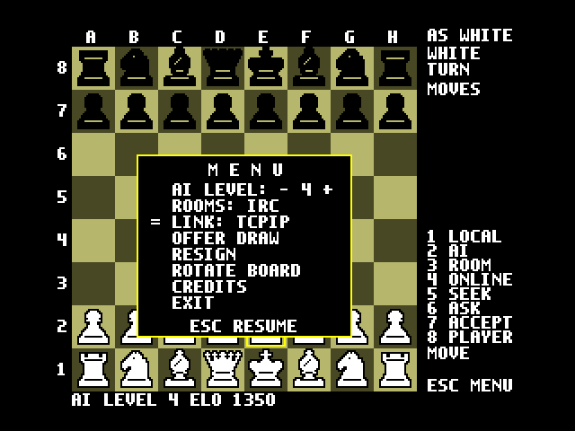  LINK: TCPIP selected | 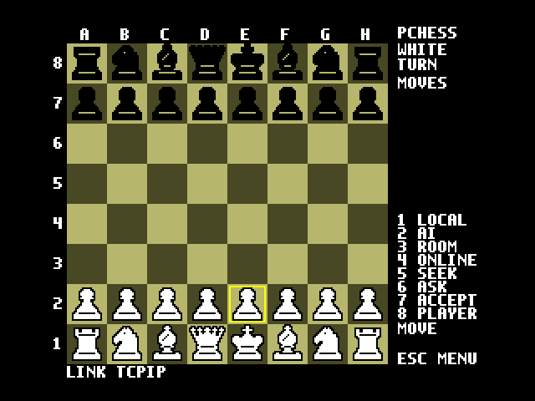  LINK TCPIP
Figure 28: Switching to the TCP/IP link
Every start of PChess uses LINK: MSXPI. Switching ends any game in progress. If no TCP/IP stack is loaded, the status line reads NO TCP/IP UNAPI - RUN INL I and the link stays MSXPI. Choose LINK: MSXPI the same way to go back.

10.3 Settings: PCHESS.INI
There is no msxpi.ini on this link. PChess reads PCHESS.INI from the current directory when the link is switched:
IRCADDR=irc.libera.chat
IRCPORT=6667
IRCNICK=yournick
All three lines are optional, and the values shown are the defaults, except the nickname: without IRCNICK it is pch and four random hex digits, a new one every time PChess starts. The IRC server must accept plain connections on that port, because the Z80 cannot use TLS; for the same reason IRC account login is not available on this link. After editing the file, switch LINK again (or restart PChess).

10.4 What works on the TCP/IP link
- 1 LOCAL: the MSX checks every move, including check, mate, stalemate, castling, en passant, promotion and the draws by repetition, the fifty-move rule and insufficient material.
- 3 ROOM: always an IRC room (section 8.3); the ROOMS row is fixed at IRC.
- 4 ONLINE, 5 SEEK, 6 ASK, 7 ACCEPT, 8 PLAYERS: as in section 7, in #msxpi on the IRC network set in PCHESS.INI.
- 2 AI needs the MSXPi server: the status line reads AI NEEDS MSXPI - ESC MENU LINK.
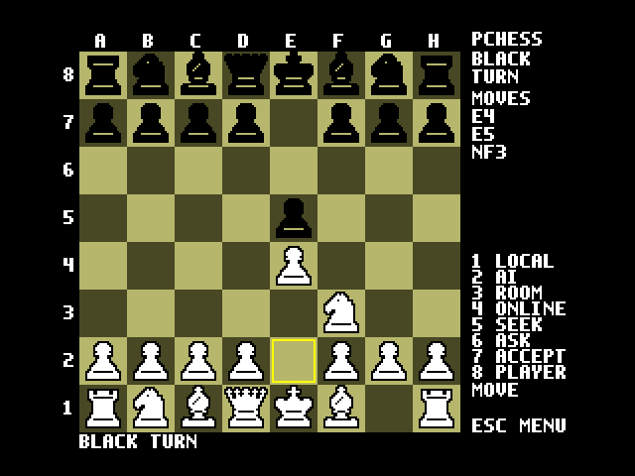
Figure 29: A local game on the TCP/IP link
Each move carries a check of the position that the MSX computes, which takes about half a second, and the connection is read once a second, so a move reaches the other player within a couple of seconds.

11. Troubleshooting
Message | Meaning / what to do
LINK ERROR - RETRY | The MSX could not reach the MSXPi server. Check the server is running and try the key again.
PCHESS NEEDS AN MSX2 | Use PCHESS1.COM on MSX1 computers.
START A GAME FIRST | A move, draw or resign with no game running. Press 1, 2, 3 or 4.
Wait before announcing again | SEEK can only be sent once per minute.
Cannot challenge now | A game or an invitation is still in progress, or you tried to invite yourself. Finish or resign the current game first; after a game ends you can invite at once.
No invitation | Key 7 was pressed but nobody has invited you.
LOBBY ACCOUNT LOGIN REQUIRED (477) | The IRC network requires a registered account. Set IRCACCOUNT/IRCPASSWORD.
WAIT ACK stays on | The opponent's MSXPi has not confirmed the move. It is resent up to three times; check both network connections.
AI DECLINES THE DRAW | The computer thinks it is ahead. Play on.
Go online first (4) | SEEK, ASK, ACCEPT or PLAYERS before going online. Press 4 and wait for LOBBY <nick>.
CANCELLED | ESC was pressed while typing a room name or nickname.
In a room; no lobby | SEEK and PLAYERS belong to the #msxpi lobby, not to an IRC room. Press 4 for the lobby.
ROOM BUSY - GAME IN PROGRESS | Two players are already playing in that IRC room. Wait, or use another room name.
Lobby nickname in use | Someone on the IRC network has your nickname. Change IRCNICK (msxpi.ini or PCHESS.INI) and press 4 again.
NO TCP/IP UNAPI - RUN INL I | LINK: TCPIP was chosen with no TCP/IP stack loaded. Exit, run MSR I or RAMHELPR I, then INL I (section 10.1).
LOW MEMORY: TPA xxxx END xxxx | Too little free memory for the TCP/IP link, usually because of many drives or resident programs. Please report both numbers.
AI NEEDS MSXPI - ESC MENU LINK | Key 2 on the TCP/IP link. Switch LINK back to MSXPI to play the computer.
TCPIP ROOMS ARE IRC | ROOMS cannot be changed on the TCP/IP link.
DNS ERROR, CONNECTION FAILED, NO NETWORK | TCP/IP link: the IRC server cannot be reached. Check the stack (INL S), IRCADDR and IRCPORT.
Limitations: games are kept in memory only (on the server, or on the MSX on the TCP/IP link). There are no chess clocks, and a game cannot be resumed after a disconnect.

